# A MINI PROJECT REPORT ON

# MOBILE AIR POLLUTION MONITORING AND BUS TRACKING SYSTEM

Submitted to JNTUH in the partial fulfillment of the Academic Requirements for the award of the degree of

BACHELOR OF TECHNOLOGY

IN

**ELECTRONICS AND COMMUNICATION ENGINEERING**

**BY**

|  |  |
| --- | --- |
| **K. Manohar Reddy** | **19QM1A0431** |
| **N.V.V. Ramana Reddy** | **19QM1A0446** |
| **P. Sai Karthika** | **19QM1A0455** |
| **R. Deepak Reddy** | **19QM1A0456** |

**UNDER THE GUIDANCE OF**

Mr. Vijaya Bhasker Reddy, M. Tech (Ph. D)

Assistant Professor



DEPARTMENT OF ELECTRONICS AND COMMUNICATION ENGINEERING

# KG REDDY COLLEGE OF ENGINEERING AND TECHNOLOGY

**(Accredited by NAAC, Approved by AICTE, New Delhi, Affiliated to JNTUH, Hyderabad)**

# Chilkur (Village), Moinabad (Mandal), R. R Dist, TS-501504

# 2022-23

DEPARTMENT OF ELECTRONICS AND COMMUNICATION ENGINEERING

# KG REDDY COLLEGE OF ENGINEERING AND TECHNOLOGY

**(Accredited by NAAC, Approved by AICTE, New Delhi, Affiliated to JNTUH, Hyderabad)**

# Chilkur (Village), Moinabad (Mandal), R. R Dist, TS-501504



CERTIFICATE

This is to certify that the Project report on “**MOBILE AIR POLLUTION MONITORING AND BUS TRACKING SYSTEM**” is a bonafide record work carried out by **K. MANOHAR REDDY (19QM1A0431), N.V.V. RAMANA REDDY (19QM1A0446), P. SAI KARTHIKA (19QM1A0455), R. DEEPAK REDDY (19QM1A0456),** in partial fulfillment for the requirement for the award of degree of **BACHELOR OF TECHNOLOGY** in **“ELECTRONICS AND COMMUNICATION ENGINEERING”, JNTUH,** Hyderabad during the year

2022-2023.

**Internal Guide**  **Head of the department**

Mr. Vijaya Bhaskar Reddy Dr. M N Narsaiah

Assistant Professor Associate Professor

**External Examiner**

ACKNOWLEDGEMENT

We wish to thanks the Management, Sri. **Ln. K. Krishna Reddy, CHAIRMAN** of KG Reddy College of Engineering and Technology for providing the facilities to complete our project work.

We would also especially like to express our extreme gratitude and sincere thanks to our beloved **Director**, **Dr. Rohit Kandakatla**, KG Reddy College of Engineering and Technology, who encouraged and given support to complete the project successfully.

At the very outset, we wish to place on record our sincere thanks and gratitude to our beloved head of the Institution, **Dr. Y. VIJAYALATA, Principal**, KG Reddy College of Engineering and Technology, who allowed us to complete this endeavor successfully.

We would like to express our sincere deep sense of gratitude and indebtedness to **Mr. M N Narsaiah, HOD**, Department of Electronics and Communication Engineering, for his significant suggestions and help in every respect to accomplish the project work. His persisting encouragement, everlasting patience and keen interest in discussions have benefited us to the extent that cannot be spanned by words. He has been the continuous source of inspiration for us throughout the work.

We would like to sincerely thank to our Minor **Project coordinator, Mrs. Dr B Vandana, Associate Professor** who stimulated many thoughts for this project and Staff-Members of Department of Electronics and Communication Engineering Department for their goodwill gestures towards us.

We would especially like to express our extreme gratitude and sincere thanks to our project guide **Mr. Vijaya Bhasker Reddy, Assistant Professor,** Department ofElectronics and Communication Engineering for his enthusiastic and innovative guidance and support.

Last but not least we would also like to thank teaching and non-teaching staff and also all my family, friends without whose support this project work would remain unfulfilled.

|  |  |
| --- | --- |
| **K. Manohar Reddy** | **19QM1A0431** |
| **N.V.V. Ramana Reddy** | **19QM1A0446** |
| **P. Sai Karthika** | **19QM1A0455** |
| **R. Deepak Reddy** | **19QM1A0456** |

# 

# ABSTRACT

We need a smart and portable management system which provides us with an efficient method to track the current location of a bus and help the stakeholders with efficient time management. And also, air pollution levels are constantly on rise. Even rural areas are affected by the overall increase in vehicle emissions, which is one of the major causes of the increase in pollution. So, a system is needed where we can constantly monitor the surrounding pollution levels. Instead of an inert system, we are proposing a more flexible one.

Combining present technology with the requirement of information transmission, we planned for a creative approach to track a bus and monitor the pollution levels at the same time using GPS and PM sensors. This system can also be used for *Accident Detection Alert System*, *Soldier Tracking System* and many more, by just making few changes in hardware and

software and widely in tracking school/colleges buses Cabs/Taxis, stolen vehicles, Etc.

Keywords­­- *Tracking, GPS, Pollution, PM Sensor, Monitoring*

Table of Contents

Certificate 1

Acknowledgement 2

ABSTRACT 4

Chapter 1 9

INTRODUCTION 9

**1.1** **OBJECTIVE** 11

Chapter 2 15

BLOCK DIAGRAM AND DESCRIPTION 15

**2.1 BLOCK DIAGRAM OF THE PROJECT** 15

**2.2 FUNCTIONS OF EACH BLOCK** 15

**v**

**LIST OF TABLES**

**Table No Name of the Table Page No**

Acronyms

S. No Abbreviation Acronym

1 Global System for Mobile Communication GSM

2. Global Positioning System GPS

3. Internet of Things IOT

4. Electronic Stability Program ESP

5. Particulate Matter Sensor PM Sensor

6.

# Chapter 1

# INTRODUCTION

# 1.1 OVERVIEW

**Air pollution** is the contamination of air due to the presence of substances in the atmosphere that are harmful to the health of humans and other living beings, or cause damage to the climate or to materials. There are many different types of air pollutants, such as gases (including ammonia, carbon monoxide, sulphur dioxide, nitrous oxides, methane, carbon dioxide and chlorofluorocarbons), particulates (both organic and inorganic), and biological molecules. Air pollution can cause diseases, allergies, and even death to humans; it can also cause harm to other living organisms such as animals and food crops, and may damage the natural environment (for example, climate change, ozone depletion or habitat degradation) or built environment (for example, acid rain). Air pollution can be caused by both human activities and natural phenomena.

Air pollution is a significant risk factor for a number of pollution-related diseases, including respiratory infections, heart disease, COPD, stroke and lung cancer. Growing evidence suggests that air pollution exposure may be associated with reduced IQ scores, impaired cognition, increased risk for psychiatric disorders such as depression and detrimental perinatal health. The human health effects of poor air quality are far reaching, but principally affect the body's respiratory system and the cardiovascular system. Individual reactions to air pollutants depend on the type of pollutant a person is exposed to, the degree of exposure, and the individual's health status and genetics.

Outdoor air pollution attributable to fossil fuel use alone causes ~3.61 million deaths annually, making it one of the top contributors to human death, with anthropogenic ozone and PM2.5 causing ~2.1 million. Overall, air pollution causes the deaths of around 7 million people worldwide each year, or a global mean loss of life expectancy (LLE) of 2.9 years, and is the world's largest single environmental health risk, which has not shown significant progress since at least 2015. Indoor air pollution and poor urban air quality are listed as two of the world's worst toxic pollution problems in the 2008 Blacksmith Institute World's Worst Polluted Places report. The scope of the air pollution crisis is large: 90% of the world's population breathes dirty air to some degree. Although the health consequences are extensive, the way the problem is handled is considered largely haphazard or neglected.

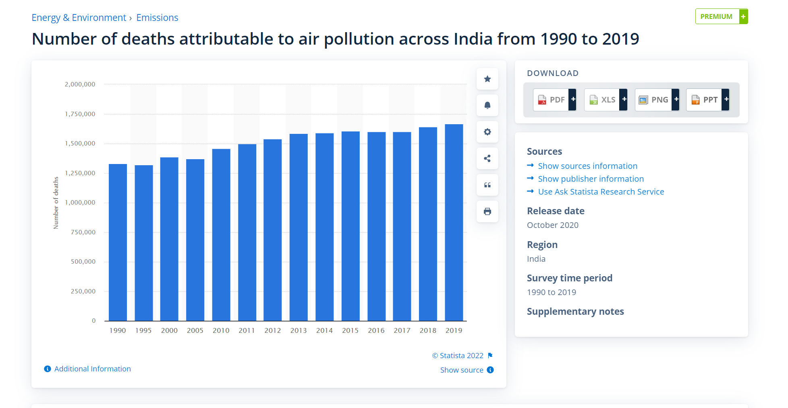 Productivity losses and degraded quality of life caused by air pollution are estimated to cost the world economy $5 trillion per year but, along with health and mortality impacts, are an externality to the contemporary economic system and most human activity, albeit sometimes being   moderately regulated and monitored. Various pollution control technologies and strategies are available to reduce air pollution. Several international and national legislation and regulation have been developed to limit the negative effects of air pollution. Local rules, when properly executed, have resulted in significant advances in public health. Some of these efforts have been successful at the international level, such as the Montreal Protocol, which reduced the release of harmful ozone depleting chemicals, and the 1985 Helsinki Protocol, which reduced sulphur emissions,while others, such as international action on climate change, have been less successful.

Figure 1.1 Number of deaths attributable to air pollution across India from 1990 to 2019

A **Vehicle Tracking System** combines the use of automatic vehicle location in individual vehicles with software that collects these fleet data for a comprehensive picture of vehicle locations. Modern vehicle tracking systems commonly use GPS or GLONASS technology for locating the vehicle, but other types of automatic vehicle location technology can also be used. Vehicle information can be viewed on electronic maps via the Internet or specialised software. Urban public transit authorities are an increasingly common user of vehicle tracking systems, particularly in large cities.

Several types of vehicles tracking devices exist. Typically, they are classified as "passive" and "active". "Passive" devices store GPS location, speed, heading and sometimes a trigger event such as key on/off, door open/closed. Once the vehicle returns to a predetermined point, the device is removed and the data downloaded to a computer for evaluation. Passive systems include auto download type that transfer data via wireless download. "Active" devices also collect the same information but usually transmit the data in near-real-time via cellular or satellite networks to a computer or data centre for evaluation.

Many modern vehicle tracking devices combine both active and passive tracking abilities: when a cellular network is available and a tracking device is connected it transmits data to a server; when a network is not available the device stores data in internal memory and will transmit stored data to the server later when the network becomes available again.

  Historically, vehicle tracking has been accomplished by installing a box into the vehicle, either self-powered with a battery or wired into the vehicle's power system. For detailed vehicle locating and tracking this is still the predominant method; however, many companies are increasingly interested in the emerging cell phone technologies that provide tracking of multiple entities, such as both a salesperson and their vehicle. These systems also offer tracking of calls, texts, web use and generally provide a wider range of options.

**1.2 INTRODUCTION TO EMBEDDED SYSTEMS**

The microprocessor-based system is built for controlling a function or range of functions and is not designed to be programmed by the end user in the same way a PC is defined as an embedded system. An embedded system is designed to perform one particular task albeit with different choices and options.

Embedded systems contain processing cores that are either microcontrollers or digital signal processors. Microcontrollers are generally known as "chip", which may itself be packaged with other microcontrollers in a hybrid system of Application Specific Integrated Circuit (ASIC). In general, input always comes from a detector or sensors in more specific word and meanwhile the output goes to the activator which may start or stop the operation of the machine or the operating system.

An embedded system is a combination of both hardware and software, each embedded system is unique and the hardware is highly specialized in the application domain. Hardware consists of processors, microcontroller, IR sensors etc. On the other hand, Software is just like a brain of the whole embedded system as this consists of the programming languages used which makes hardware work. As a result, embedded systems programming can be a widely varying experience.

An embedded system is combination of computer hardware and software, either fixed incapability or programmable, that is specifically designed for particular kind of application device. Industrial machines, automobiles, medical equipment, vending machines and toys (as well as the more obvious cellular phone and PDA) are among the myriad possible hosts of an embedded system. Embedded systems that are programmable are provided with a programming interface, and embedded systems programming id specialized occupation.

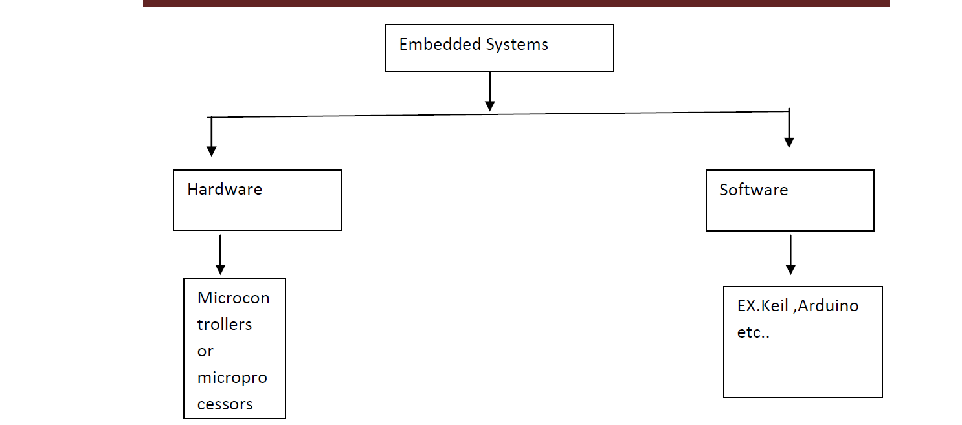

Figure 1.2 Block diagram of embedded system

Figure1.1 illustrate the Block diagram of Embedded System (ES consists of

hardware and software part which again consists of programming language and physical peripherals respectively*).* On the other hand, the microcontroller is a single silicon chip consisting of allinput, output and peripherals on it. A single microcontroller has the following features:

1. Arithmetic and logic unit

2. Memory for storing program

3. EEPROM for non-volatile and special function registers

4. Input/output ports

5. Analog to digital converter

6. Circuits

7. Serial communication ports

**1.3 APPLICATIONS OF EMBEDDED SYSTEM**

We are living in the embedded world. You are surrounded with many embedded products and your daily life largely depend on the proper functioning’s of these gadgets, television, radio, CD layer of your living room, washing machines or microwave oven in your kitchen, card readers, access controllers, palm devices of your work space enable to do many of your tasks very effectively. Apart from all these, many controllers embedded in your car take care of your car operation between the bumper and most of the times tend to ignore all these controllers.

In recent days you are showered with variety of information about these embedded controllers in many places. All kind of magazines and journals regularly dish out details about latest technologies, new devices: fast applications which make you believe that your basic survival is controlled by these embedded products. Now you can agree to that fact these embedded products have successfully invaded into our world. You must be wandering about these embedded controllers or systems.

The computer you use to compose your mails, or create a document or analyze the database is known as standard desktop computer. These desktop computers are manufactured to serve many purposes and applications.

**1.4 OBJECTIVE**

The difficulties faced by people when a bus fails or one fails to board the bus on time lead to confusion among the people. Also, air pollution is one of the major environmental issues that cannot be ignored. Inhaling pollutants for a long time causes damage to human health.

A bus-tracking app forms part of the entire system of a real time bus management and serves as a convenient access point when downloaded onto the phone of the users. The bus-tracking app provides parents and authorities a map view of the current position of the bus with information of where the bus is currently located.

To begin with, a bus-tracking app uses modern GPS technology. Thus, a GPS device installed within a bus can transmit its location in real time, which can be displayed on a map.

As we could imagine, a situation where students travel on a daily basis forms an important segment of bus travel. When there is a sudden repair in the bus or the bus has diverged from the current route, it creates a dilemma for the passengers on the bus. They get confused whether to board another bus or to wait until the current bus gets repaired.

As mentioned above, the buses are installed with a GPS sensor that is connected to an app. The College management/College authorities (Transport In-charge) can track it from their respective places, meanwhile parents can track it on their mobile phones.

If there is any unplanned delay or a repair in the bus, this system also conveniently facilitates the driver in communicating directly with the college management and with the parents. Within the bus tracking application, we are adding another feature to monitor air pollution.

Nowadays, air pollution is one of the major risk factors which harms the environment. Several studies have shown the detrimental effects of air pollution on human health and wellbeing among all the air pollutants, particulate matter (PM) pollution is one of the particular concerns to worry about.

Particulate matter is classified into PM 2.5 and PM10, based upon their particle diameter.  Existing networks of PM 2.5 and PM 10 monitors have shown that Particulate Matter concentrations have been increased. Due to their tiny size, they can penetrate deep into the lungs and mix with the blood stream. Which leads to cardiovascular and pulmonary diseases.

1. The primary aim of this project is to track the bus location and monitor air pollution levels within the environment through a mobile application.
2. To provide the information and location of the bus and amount of pollution during the journey to various places to the stakeholders for taking care and prior precautions.
3. To increase time efficiency, safety and with air pollution monitoring we are trying to create awareness on personal health safety.
4. The positional information or the coordinates of each visiting points are stored in a database, which later can be viewed on a display screen using digital maps. However, the users have to connect themselves to the web server with the respective vehicle ID stored in the database and only then she/he can view the location of vehicle travelled.
5. Analyse particulate matter in the surrounding by interfacing SDS sensor with ESP8266.
6. Understand the behaviour of particulate matter with respect to variation of temperature and humidity.

# Chapter 2

# LITERATURE STUDY

Payali Das, [1] proposed system is a low cost, innovative Air Pollution Monitoring Device (APMD) along with the evaluation of its advanced features. An on-board Particulate Matter (PM) sensor is designed to measure PM 2.5 and PM 10. APMD additionally has electrochemical sensors to measure carbon monoxide, Sulphur dioxide, nitrogen dioxide, ozone, besides temperature and humidity sensors. The node is equipped with a solar energy harvesting unit and a rechargeable battery as a backup to power up the module. By utilizing an on-board GPS subsystem, APMD packs all these gathered air quality data in a frame with physical location, time, and date, and sends them to a cloud server. The node can communicate through Wi-Fi and NB-IoT connectivity. For validating the quality of sensing, the developed APMD was co-located with an accurate reference sensor node and a series of field data were collected over seven days. In a fully ON state, the on-board PM sensor saves up to 94% energy while maintaining root mean square error (RMSE) of 0.58 for PM 2.5 and 2.5 for PM 10. A power control mechanism is also applied on the PM sensor to control the speed of the fan by applying a pulse width modulated (PWM) signal at the switch connected to the power supply of fan. At 100 ms switching period with 30% duty cycle, the on-board PM sensor is 97% energy efficient compared to the commercial sensor, while maintaining sensing error (RMSE) as low as 0.7 for PM 2.5 and 2.7 for PM 10. Our outdoor deployment studies demonstrate that the designed APMD is 90.8% more power efficient than the reference setup with significantly higher coverage range, while maintaining an acceptable range of sensing error.

Muhammad Fareez Mohd Ainul Kakeem, [2] proposed system is a simple Internet of Things (IoT) prototype for users to view or for authorities to monitor the bus activity via a mobile application on the available bus seats, bus schedule, and bus activities. The design prototype is using the NodeMCU ESP32 controller which communicates using Wi-Fi. IR sensor and GPS module are used for the input sensors. Blynk and cloud applications are used to present the data analysis on mobile apps. The mobile application was designed where users can view the number of passengers on the bus and the location of the bus. The online database is designed to capture all records of the bus passengers entering and leaving the bus. the result presents the GPS module able to get the exact location of the bus and detect its latitude and longitude. Passengers’ activities on entering and leaving the bus are recorded every 5 seconds. The number of passengers has increased to 20 passengers in 3 minutes at one bus stop. The number of passengers leaving the bus also are recorded and analyzed. These activities can be monitored by the authorities which helps for good services, time, and management for the bus transport services.

Yuhan Huang, [3] proposed system uses the on-road remote sensing (RS) technology for fast, accurate, and cost-effective identification of high-emitting vehicles as an enforcement program for improving urban air quality. Using large emission datasets from chassis dynamometer testing, RS, and air quality monitoring, we found that significant percentages of in-use petrol and LPG vehicles failed the emission standards, particularly the high-mileage fleets. The RS enforcement program greatly cleaned these fleets, in terms of high-emitter percentages, fleet average emissions, roadside and ambient pollutant concentrations, and emission inventory. The challenges of the current enforcement program are conservative setting of cut points, single-lane measurement sites, and lack of application experience in diesel vehicles. Developing more accurate and vertical RS systems will improve and extend their applications.

Baichoo Bibi Humaira, [4] proposed system is to have an efficient Android Bus Tracking App, it needs to Our implementation involves the tracking of real-time location of the bus using Global Positioning System (GPS) and Global System for Mobile Communication / General Packet Radio Service (GSM/GPRS) technology. To display the bus on the map in the developed application, Google Map API is used. Hence, user will be able to constantly keep track of buses using the Application. The distance and time to reach the destination and the time for the bus to reach the user will also be displayed on the screen. For user to receive this information along with the markers on the map, an Internet connection is needed, be it Wi-Fi or mobile data. In case of no Internet access, SMS will be used as the second communication option.

Temesegan Walelign Ayele, [5] proposed system is an IoT based air pollution monitoring and prediction system. This system can be utilized for monitoring air pollutants of a particular area and to air quality analysis as well as forecasting the air quality. The proposed system will focus on the monitoring of air pollutants focus with the combination of IoT with a machine learning algorithm called Recurrent Neural Network more specifically Long Short-Term Memory (LSTM).

Vladimir Shakhov, [6] proposed system is a monitoring system, which sensors installed on vehicles. They offer the corresponding approach. The results help to optimize, rationalize, and manage efficient systems for monitoring of air pollution.

R. Santhana Krishnan, [7] proposed system is a new Android Application based Smart Bus Transportation System which guides the passengers in booking the bus tickets using the Android Application and it also helps the passengers to keep an update on bus location based on their request. This system also sends alert message few minutes in advance to the passengers before the bus reaches the passengers boarding point. This system also sends the precautionary instruction priorly to the passengers that have to be followed while travelling in the bus. In order to provide additional safety to the passengers the temperature of the passengers is monitored and intimated to the bus in change before they are permitted into the bus.

Siti Asma, [8] proposed system is for the convenience of those who want to plan their journey with shuttle buses, two applications are proposed. One application will track the location of the bus and the other application will be used by the students. Both proposed applications will be used along with an Android phone since it is mostly used by students. The main objectives of developing this application are to inform users regarding the current bus location and estimated arrival time. This application also provides users real-time forum so they can start conversations with others with the same application. Besides, the driver's profile is also included for the user's future reference.

Hina Gull, [9] proposed IoT based Bus Tracking System, will introduce a tracking website and an android application for the school admin, drivers of the bus and the parents. Proposed system will provide the admin with the charge of adding new bus driver and new student to the driver list. Furthermore, the application itself will generate a fixed QR code for each student that will be placed on a card that contain the student personal information. Also, proposed system will track the bus location through the driver mobile. Subsequently, the parents' application will display a map that show the current bus position and it will be updated after each period, and the intervals between each update will be short as possible to ensure the safety of everyone. Moreover, there will be different types of notifications that will be received by the school admin or parents' or both. For instance, school admin and parents will receive a notification if the bus is out of schedule, and there will be another notification will be received by the parents' if there is any change in the daily bus schedule.

[S. Vigneshwaran](https://ieeexplore.ieee.org/author/37087245587), [10] proposed system is a mix of present innovation with the prerequisite of data transmission, they got ready for the imaginative methodology of “Plan of Bus Tracking and Fuel Monitoring System”. To beat the disadvantages of the past techniques for paper based and we acquaint a task with track a vehicle utilizing GPS and GSM. This Vehicle Tracking System can likewise be utilized for Accident Detection Alert System, Soldier Tracking System and some more, by simply rolling out not many improvements in equipment and programming and broadly in following Cabs/Taxis, taken vehicles, school/universities transports and so on. The transport following framework is a practical and productive framework. Utilizing this framework four application will be created. First application is setting up correspondence between school server and transport framework which is equipped for giving constant information with respect to the present area of transports. Second application is sending a gathering message for example ready messages to the understudies holding up at the following stop, changes in current course, transport number, and so forth., thus it spares the hour of understudies. Third application is period. There is no need of time of plastic vehicle passes. Last application is building up a crisis dealing with framework which will send ready messages all the while to school, police and rescue vehicle in the event of mishaps.

[Rezowana Akter,](https://ieeexplore.ieee.org/author/37088378685) [11] proposed system is to offer an effortless transportation facility by minimizing the problems faced by passengers, drivers and the concerned authorities with the help of a handy android application. Our system uses Radio Frequency Identification [RFID], Global Positioning System [GPS], and an android application for passenger management and real-time tracking features for offering a satisfying bus fare calculation.

[Hongjie Liu](https://ieeexplore.ieee.org/author/37695427000), [12] proposed system is to combine the advantages of the two prediction models, this paper proposes a long short-term memory (LSTM) and Artificial neural networks (ANN) comprehensive prediction model based on spatial-temporal features vectors. The long-distance arrival-to-station prediction is realized from the dimension of time feature, and the short-distance arrival-to-station prediction is realized from the dimension of spatial feature, thereby realizing the bus-to-station prediction. Besides, experiments were conducted and tested based on the entity dataset, and the result shows that the proposed method has high accuracy among bus arrival prediction problems.

[Pau Ferrer-Cid](https://ieeexplore.ieee.org/author/37087121831), [13] proposed system is to compare two techniques that rely on structured data, one based on statistical methods and the other on signal smoothness, with a baseline technique based on the distance between nodes and that does not rely on the measured signal data. To compare these techniques, the sensor signal is reconstructed with a supervised method based on linear regression and a semi supervised method based on Laplacian interpolation, which allows reconstruction even when data is missing. The results, on data sets measuring O 3, NO 2, and PM 10, show that the signal smoothness-based technique behaves better than the other two, and used together with the Laplacian interpolation is near optimal with respect to the linear regression method. Moreover, in the case of heterogeneous networks, the results show a reconstruction accuracy similar to the in-situ calibrated sensors. Thus, the use of the network data increases the robustness of the network against possible sensor failures.

[Ditsuhi Iskandaryan](https://sciprofiles.com/profile/974489), [14] proposed system covers the revision of the studies related to air pollution prediction using machine learning algorithms based on sensor data in the context of smart cities. Using the most popular databases and executing the corresponding filtration, the most relevant papers were selected. After thorough reviewing those papers, the main features were extracted, which served as a base to link and compare them to each other. As a result, we can conclude that: (1) instead of using simple machine learning techniques, currently, the authors apply advanced and sophisticated techniques, (2) China was the leading country in terms of a case study, (3) Particulate matter with diameter equal to 2.5 micrometers was the main prediction target, (4) in 41% of the publications the authors carried out the prediction for the next day, (5) 66% of the studies used data had an hourly rate, (6) 49% of the papers used open data and since 2016 it had a tendency to increase, and (7) for efficient air quality prediction it is important to consider the external factors such as weather conditions, spatial characteristics, and temporal features.

Zena A. Aziz, [15] proposed system is based on Wireless Sensor Networks, which is a revolutionary system that can detect, calculate, and gather information from the real world and, based on the gathered data relay data to the consumer. These modern networks enable the world to be assessed at high resolutions which is one of the most important things. Research on pollution sensors and monitoring systems is provided in this report.

[B. Perumal](https://ieeexplore.ieee.org/author/37085712162). [16] proposed system is a framework for tracking air pollution. The proposed model is regulated by an Arduino mini control. Air pollution observance system is intended to trace and evaluate air quality in real time with the knowledge retrieved from an overseas server and saved online. Measurements of air quality depend on the components, which are measured in terms of Million Metrics (PPM) and analyzed in Microsoft Excel. The air quality measurements taken by the established system were also precise.

# Chapter 3

# METHODOLOGY

The proposed system consists of various sensors i.e., GPS sensor, Particulate Matter sensor (SDS 011), AHT10 sensor, used for humidity and temperature monitoring. The PM (Particulate Matter) sensor takes in data on the present air-borne particles under 2.5 and 10 μm. It updates at rapid time intervals.

The GPS Sensor that is connected to the bus sends in data to the server through GSM. Based on the proposed system these sensors are interfaced to an ESP8266 Microcontroller. Both the air pollution and GPS information can be accessed through a Mobile Application.

### 

Figure 3. An Overview of the complete working process

### Above fig. 3.1 illustrates the overall working of the air pollution and bus tracking system. Starting from the host to the receiver.

### **3.1 BLOCK DIAGRAM**

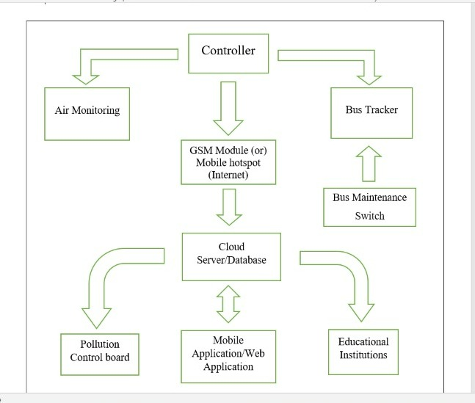

Figure 3. Block diagram of Mobile Air Pollution Monitoring and Bus Tracking System

### **3.2 FUNCTIONS OF EACH BLOCK**

**POWER SUPPLY:**

The main purpose of a power supply is to convert electric current from a source to the correct voltage, current, and frequency to power the load. It supplies electric power to an electric load.

**MICROCONTROLLER:**

The microcontroller is used to manipulate the serial operation based on the program present in the output taken from one of the four ports.

**GSM MODULE:**

Global system for mobile communication (GSM) is a globally accepted standard for digital cellular communication. GSM is the name of a standardisation group established in 1982 to create a common European mobile telephone standard that would formulate specifications for a pan-European mobile cellular radio system operating at 900 MHz It is to define the procedures for second-generation digital mobile networks that are used by the devices such as mobile phones.

**GPS RECEIVER:**

GPS, in full Global Positioning System, space-based radio-navigation system that broadcasts highly accurate navigation pulses to users on or near the Earth. In the United States’ Navstar GPS, 24 main satellites in 6 orbits circle the Earth every 12 hours. In addition, Russia maintains a constellation called GLONASS (Global Navigation Satellite System).

**CLOUD SERVER:**

A cloud server is a pooled, centralised server resource that is hosted and delivered over a network—typically the Internet—and accessed on demand by multiple users. Cloud servers can perform all the same functions of a traditional physical server, delivering processing power, storage and applications. It acts as a database.

**MOBILE APPLICATION:**

The mobile application is used to access the data from the server wirelessly and control the functions of the received data. It also interprets data into the user viewable format.

**AHT10 SENSOR:**

AHT10 is a digital temperature and humidity sensor embedded for reflow soldering. The dual-row flat leadless SMD package has a 4x5mm bottom and a height of 1.6mm. The minuscule sensor has a power supply range of 1.8-3.6V, but 3.3V is the recommended operating voltage.

**SDS 011 SENSOR:**

SDS 011 is an air quality measurement sensor which can be used to get dust particles and smoke concentration in the air. More precisely, it can measure particulate matter (PM) concentrations in the air. It can detect the dust particles concentration between 0.3 to 10um. Most importantly, Nova PM dust sensor provides an interrupt-based response when the concentration of dust particles changes in the air and the response time is less than 10 seconds. The operating voltage range is 4.7-5.3V which makes it suitable to use with standard voltage of 5 volts. Furthermore, it has a UART module and PWM outputs which can be used to get output from the SDS011 sensor.

**ESP8266:**

The ESP8266 is a low-cost Wi-Fi microchip. With built-in TCP/IP networking software, and microcontroller capability, produced by Espressif Systems in Shanghai, China. The ESP8266 is capable of either hosting an application or offloading all Wi-Fi networking functions from another application processor.

# Chapter 4

HARDWARE DESCRIPTION

NODEMCU:

NodeMCU is a low-cost open source IoT platform. It initially included firmware which runs on the ESP8266 Wi-Fi SoC from Espressif Systems, and hardware which was based on the ESP-12 module.

However, as a chip, the ESP8266 is also hard to access and use. You must solder wires, with the appropriate analog voltage, to its pins for the simplest tasks such as powering it on or sending a keystroke to the “computer” on the chip. You also have to program it in low-level machine instructions that can be interpreted by the chip hardware. This level of integration is not a problem using the ESP8266 as an embedded controller chip in mass-produced electronics. It is a huge burden for hobbyists, hackers, or students who want to experiment with it in their own IoT projects.



NodeMCU is an open-source Lua based firmware and development board specially targeted for IoT based Applications. It includes firmware that runs on the ESP8266 Wi-Fi SoC from Espressif Systems, and hardware which is based on the ESP-12 module.

NodeMCU ESP8266 Specifications & Features:

* Microcontroller: Tensilica 32-bit RISC CPU Xtensa LX106
* Operating Voltage: 3.3V
* Input Voltage: 7-12V
* Digital I/O Pins (DIO): 16
* Analog Input Pins (ADC): 1
* UARTs: 1
* SPIs: 1
* I2Cs: 1
* Flash Memory: 4 MB
* SRAM: 64 KB
* Clock Speed: 80 MHz
* USB-TTL based on CP2102 is included onboard, Enabling Plug n Play
* PCB Antenna
* Small Sized module to fit smartly inside your IoT projects

The NodeMCU ESP8266 development board comes with the ESP-12E module containing the ESP8266 chip having Tensilica Xtensa 32-bit LX106 RISC microprocessor. This microprocessor supports RTOS and operates at 80MHz to 160 MHz adjustable clock frequency. NodeMCU has 128 KB RAM and 4MB of Flash memory to store data and programs. Its high processing power with in-built Wi-Fi / Bluetooth and Deep Sleep Operating features make it ideal for IoT projects.

NodeMCU can be powered using a Micro USB jack and VIN pin (External Supply Pin). It supports UART, SPI, and I2C interface.

NodeMCU ESP8266 Pinout diagram:

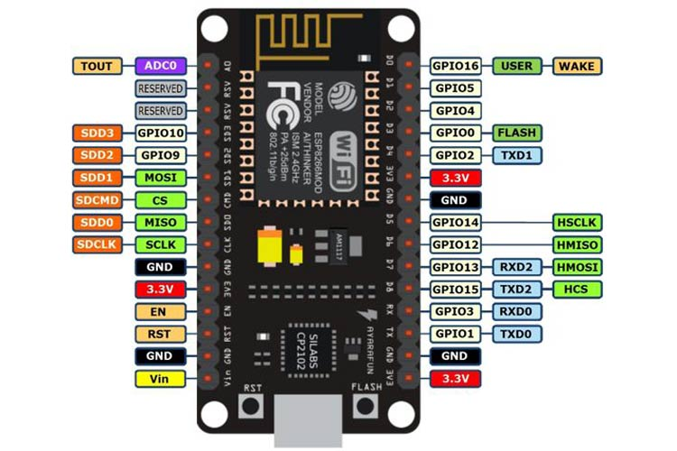

For practical purposes ESP8266 NodeMCU V2 and V3 boards present identical pinouts. While working on the NodeMCU based projects we are interested in the following pins.

Power pins (3.3 V).

Ground pins (GND).

Analog pins (A0).

Digital pins (D0 – D8, SD2, SD3, RX, and TX – GPIO XX)

Most ESP8266 NodeMCU boards have one input voltage pin (Vin), three power pins (3.3v), four ground pins (GND), one analog pin (A0), and several digital pins (GPIO XX).

pin    Code               Arduino alias

A0       A0                               A0

D0       GPIO 16                     16

D1       GPIO 5                       5

D2       GPIO 4                       4

D3       GPIO 0                       0

D4       GPIO 2                       2

D5       GPIO 14                     14

D6       GPIO 12                     12

D7       GPIO 13                     13

D8       GPIO 15                     15

SD2     GPIO 9                       9

SD3     GPIO 10                     10

RX      GPIO 3                       3

TX       GPIO 1                       1

BREAD BOARD:

A breadboard allows for easy and quick creation of temporary electronic circuits or to carry out experiments with circuit design. Breadboards enable developers to easily connect components or wires thanks to the rows and columns of internally connected spring clips underneath the perforated plastic enclosure.

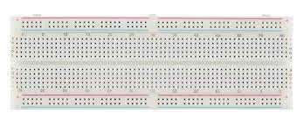

As the name suggests, the term breadboard can be derived from two terms namely bread & board. Initially, this was used to cut the bread into pieces. Further, it was called a breadboard & it was used in electronics projects and electronic devices in the year 1970. A breadboard is also known as a solderless board because the component used on the breadboard does not need any soldering to connect to the board, so it can be reused.

Compared to more permanent circuit connection methods, modern breadboards have high parasitic capacitance, relatively high resistance, and less reliable connections, which are subject to jostle and physical degradation. Signaling is limited to about 10 MHz, and not everything works properly even well below that frequency.

Breadboards have evolved over time, with the term now being used for all kinds of prototype electronic devices. For example, US Patent 3,145,483, was filed in 1961 and describes a wooden plate breadboard with mounted springs and other facilities. US Patent was filed in 1967 and refers to a particular layout as a Printed Circuit Breadboard. Both examples refer to and describe other types of breadboards.

The breadboard has strips of metal underneath the board and connect the holes on the top of the board. The metal strips are laid out as shown below. Note that the top and bottom rows of holes are connected horizontally and split in the middle while the remaining holes are connected vertically.

The specifications & features of a breadboard:

* Distribution Strips are two.
* Wire Size is 21 to 26 AWG wire.
* Tie Points are two hundred.
* Withstanding Voltage is 1,000V AC.
* Tie points within IC are 630.
* Insulation Resistance is DC500V or 500MΩ
* Dimension is 6.5*4.4*0.3 inch.
* Rating is 5Amps.

AHT-10 SENSOR:

AHT10 is a digital temperature and humidity sensor embedded for reflow soldering. The dual-row flat leadless SMD package has a 4x5mm bottom and a height of 1.6mm.

The AHT10 sensor is equipped with a newly designed ASIC, an improved MEMS semiconductor capacitive humidity sensing element and a standard on-chip temperature sensing element. It can output a calibrated digital signal in standard I2C format. The minuscule sensor has a power supply range of 1.8-3.6V, but 3.3V is the recommended operating voltage.

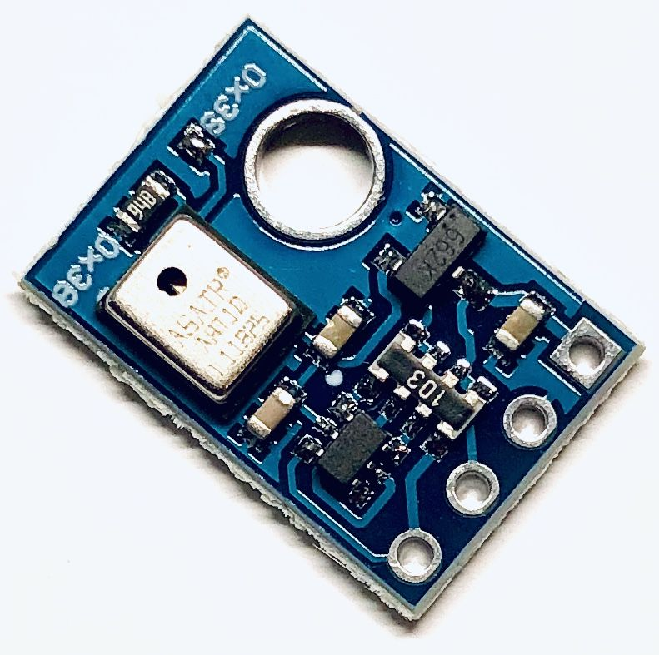

Pinout:

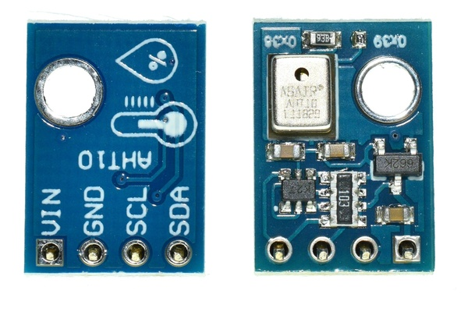

1. Vin: Supply Voltage

2. Gnd: Ground

3. SCL: Serial Clock This pin is used for communication synchronization between the microprocessor and AHT10 sensor. Since the interface contains completely static logic, there is no minimum SCL frequency.

4. SDA: Serial Data The SDA pin is used for data input and output of the sensor. SDA is active on the rising edge of the serial clock (SCL) when a command is sent to the sensor, and SDA must remain stable when SCL is high. After the falling edge of SCL, the SDA value can be changed. Features and Specifications

Features and Specifications:

1. Interface type: I2C

2. Working voltage: 1.8 – 6.0 V

3. Interface size: 4*2.54mm pitch

4. Humidity accuracy: typical ± 2%

5. Humidity resolution: 0.024%

6. Temperature accuracy: typical ± 0.3 ° C

7. Temperature resolution: Typical 0.01 °C

8. Working temperature: -40°C–85°C

The AHT10, a new generation of temperature and humidity sensors, sets a new standard in size and intelligence.

The sensor outputs a calibrated digital signal in standard I2C format. The AHT10 is equipped with a newly designed ASIC-specific chip, an improved MEMS semiconductor capacitive humidity sensing element and a standard on-chip temperature sensing element.

SDS 011 SENSOR:

SDS 011 is an air quality measurement sensor which can be used to get dust particles and smoke concentration in the air. More precisely, it can measure particulate matter (PM) concentrations in the air. It can detect the dust particles concentration between 0.3 to 10um.

Most importantly, Nova PM dust sensor provides an interrupt-based response when the concentration of dust particles changes in the air and the response time is less than 10 seconds. The operating voltage range is 4.7-5.3V which makes it suitable to use with standard voltage of 5 volts. Furthermore, it has a UART module and PWM outputs which can be used to get output from the SDS011 sensor.

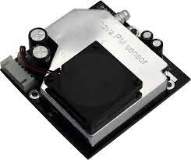

Features:

* Accurate and Reliable: laser detection, stable, good consistency.
* Quick response: response time is less than 10 seconds when the scene changes.
* Easy integration: UART output (or IO output can be customized), fan built-in.
* High resolution: the resolution of 0.3ug/m3.

Applications:

* PM2.5 Detector
* Purifier
* Air Exchangers
* Filtering system

GSM:

Global system for mobile communication (GSM) is a globally accepted standard for digital cellular communication. GSM is the name of a standardization group established in 1982 to create a common European mobile telephone standard that would formulate specifications for a pan-European mobile cellular radio system operating at 900 MHz.

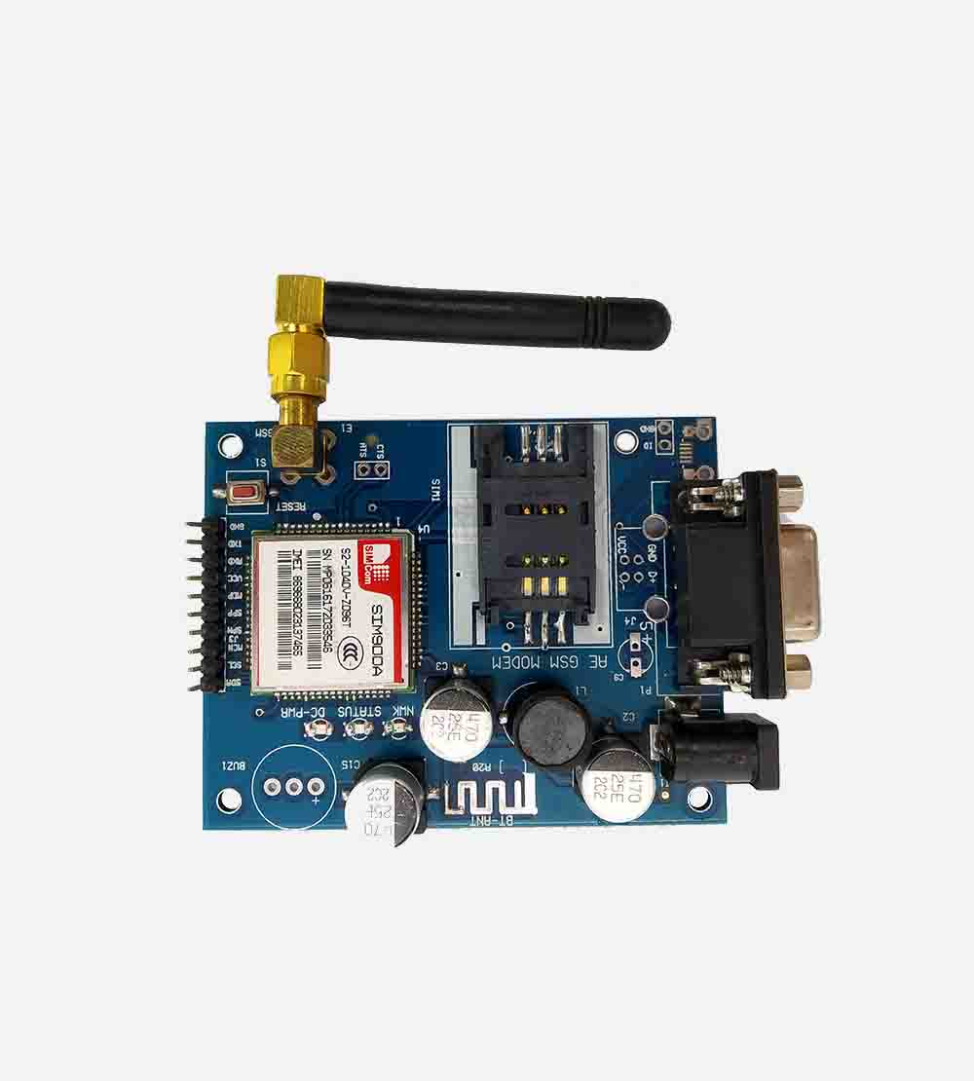

Global System for Mobile communications, is a digital cellular communications system, which has rapidly gained acceptance and market share worldwide, although it was initially developed in a European context. In addition to digital transmission, GSM incorporates many advanced services and features, including ISDN compatibility and worldwide roaming in other GSM networks.

GSM SERVICES:

1.Tele-services

2. Bearer or Data Services

3. Supplementary services

Tele-services: Telecommunication services that enable voice communication via mobile phones Offered services, Mobile telephony, Emergency calling

Bearer or Data Services: Include various data services for information transfer between GSM and other networks like PSTN, ISDN etc at rates from 300 to 9600 bps ,Short Message Service (SMS) up to 160 character alphanumeric data transmission to/from the mobile terminal unified.

Supplementary services: Call related services like Call Waiting- Notification of an incoming call while on the handset, Call Hold- Put a caller on hold to take another call, Call Barring- All calls, outgoing calls, or incoming calls, Call Forwarding- Calls can be sent to various numbers defined by the user, Multi Party Call Conferencing - Link multiple calls together

1.CLIP – Caller line identification presentation

2. CLIR – Caller line identification restriction

Characteristics of GSM Standard:

Fully digital system using 900,1800 MHz frequency band.

1. TDMA over radio carriers (200 KHz carrier spacing)

2. 8 full rate or 16 half rate TDMA channels per carrier

3. User/terminal authentication for fraud control.

4. Encryption of speech and data transmission over the radio path

5. Full international roaming capability.

6. Low speed data services (upto 9.6 Kb/s).

7. Compatibility with ISDN

Security in GSM:

On air interface, GSM uses encryption and TMSI instead of IMSI.

λ SIM is provided 4-8 digit PIN to validate the ownership of SIM

λ 3 algorithms are specified : -

A3 algorithm for authentication

- A5 algorithm for encryption

- A8 algorithm for key generation